**Assignment 1**

**Student Name**: Sahil Kaundal **UID:** 21BCS8197

**Branch**: CSE(LEET) **Section/Group:** 807/B

**Semester**: 4th **Date of Performance**: 22/03/2022

**Subject Name**: Computer Networks **Subject Code:** 20CSP-256

**Q1. Draw a diagram with networking devices required to do communication between two devices on two different networks.**

**Answer:**

We can communicate two different devices on two different networks using router.

We cannot directly ping two different networks (like switch one two switch two).

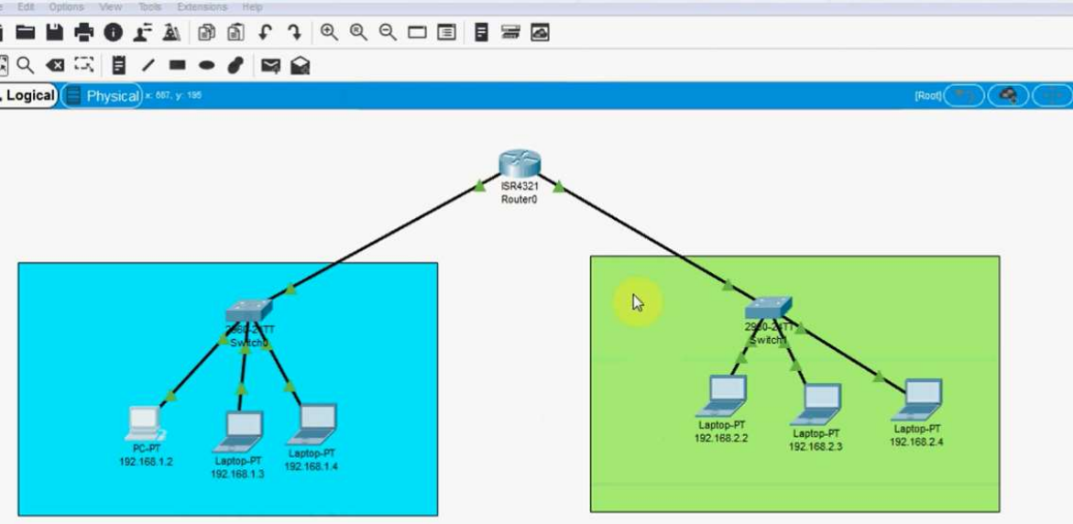

**STEP 1:** ASSIGN IPs TO ALL PCs

**STEP 2:** ASSIGN DIFFERENT GATEWAYS TO DIFFERENT NETWORKS LIKE: 192.168.1.1 AND 192.168.2.1

**STEP 3:** CONFIGURATION ROUTER ADD BOTH GATEWAY ON ROUTER (ip add 192.168.1.1 255.255.255.0) and same for other one.

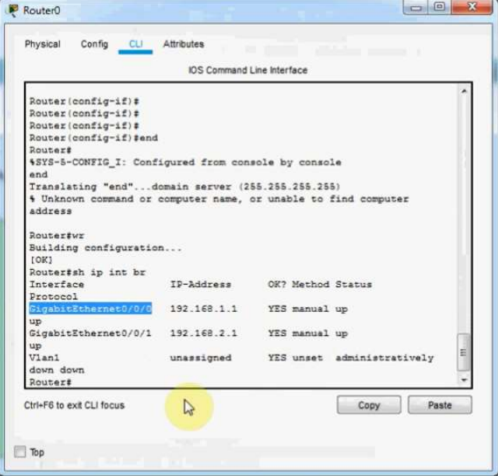

**STEP 4:** PING IP FROM ONE PC TO OTHER OF DIFFERENT GATEWAYS.

**OUTPUT:**

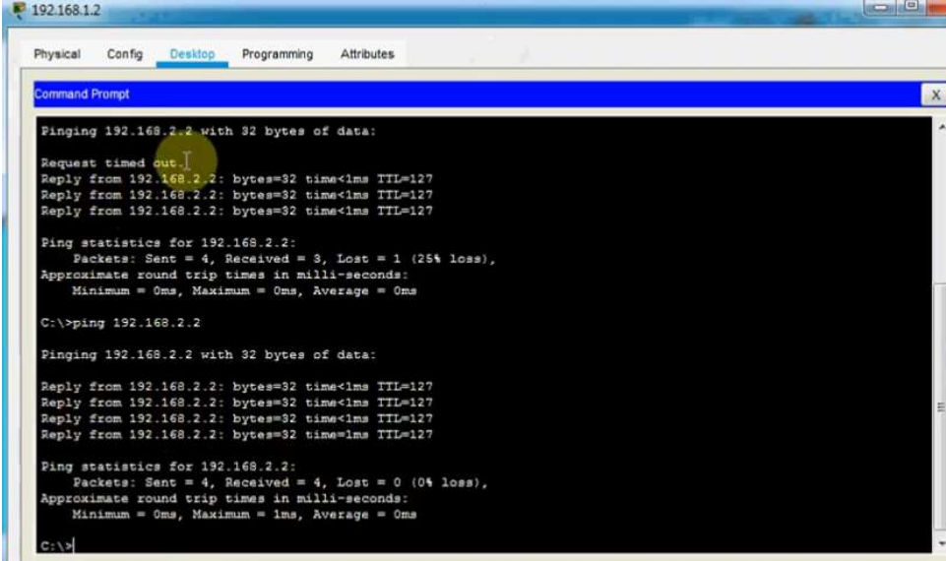

**Q2. Draw the diagrams that represents the star and ring topology and also explain its applications and disadvantages.**

**Answer:**

**Network topologies:** Network topologies describe the methods in which all the elements of a network are mapped. The topology term refers to both the physical and logical layout of a network.

**Star Topology**

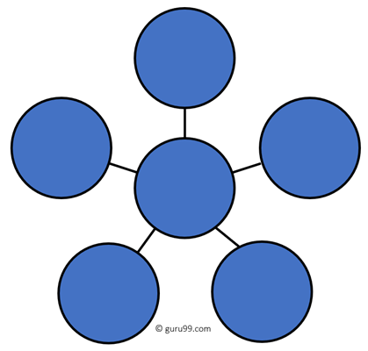

In the star topology, all the computers connect with the help of a hub. This cable is called a central node, and all other nodes are connected using this central node. It is most popular on LAN networks as they are inexpensive and easy to install.

**Disadvantages:**

Here are cons/drawbacks of using Star:

* If the hub or concentrator fails, attached nodes are disabled.
* Cost of installation of star topology is costly.
* Heavy network traffic can sometimes slow the bus considerably.
* Performance depends on the hub’s capacity
* A damaged cable or lack of proper termination may bring the network down.

**Applications:**

* Star topology is the most used and popular topology using LANs. The star topology was first seen by ARCNET [Attached Resource Computer Network]
* Star topology is used in small networks.
* They are used in small organizations
* They use LAN connections for high speed up to 100MBPS.
* Star Topology is used in small institutes.
* All the devices are connected to each other via HUB or SWITCH
* All the nodes are connected to the central HUB and if any node is failed doesn’t harm or damage the entire network.
* These star networks are quiet cheaper compares to other network topologies.
* They are very easy in maintenance and up gradation.
* They are scalable node can be added any time user request or demand.

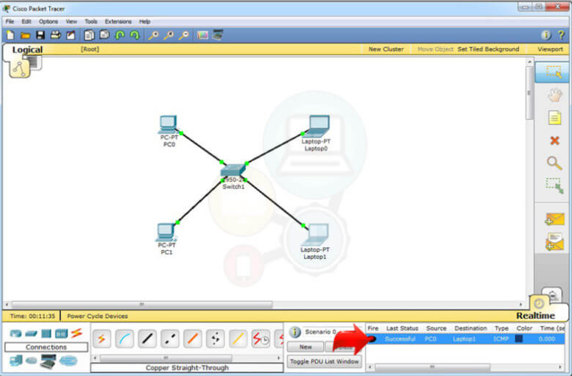

**Ring Topology**

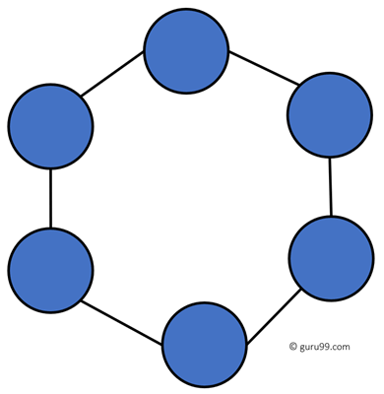

In a ring network, every device has exactly two neighbouring devices for communication purpose. It is called a ring topology as its formation is like a ring. In this topology, every computer is connected to another computer. Here, the last node is combined with a first one.

This topology uses token to pass the information from one computer to another. In this topology, all the messages travel through a ring in the same direction.

**Disadvantages:**

Here are drawbacks/cons of ring topology:

* Unidirectional traffic.
* Break in a single ring can risk the breaking of the entire network
* Modern days high-speed LANs made this topology less popular.
* In the ring, topology signals are circulating at all times, which develops unwanted power consumption.
* It is very difficult to troubleshoot the ring network.
* Adding or removing the computers can disturb the network activity.

**Applications:**

* Ring Topology is deployed in a Local area network (LAN) and a Wide area network (MAN) as well.
* SONET (Synchronous optical network) fiber networks in the Telecommunication domain uses Ring topology quite extensively.
* It provides a standard for global telecommunication networks which will replace many older systems and it offers many advantages like:

1. Reliable network
2. Low Capital investment
3. Seamless connectivity with multiple service providers
4. Futuristic in technology

* It also makes use of the bidirectional capability of this dual-ring topology to route traffic in another direction if the connection is lost with a node.
* It is also used in educational institutions due to its lower cost of operation and few commercial establishments also use it. Many organizations have a ring network is as a fallback system (backup) for their existing network.

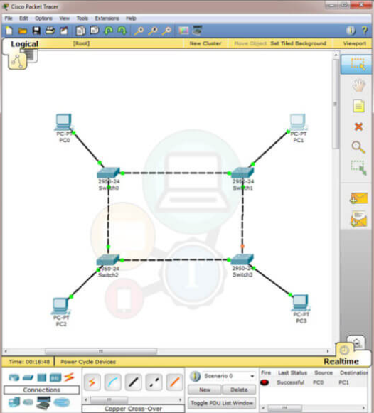

**Evaluation Grid (To be created as per the SOP and Assessment guidelines by the faculty):**

|  |  |  |  |
| --- | --- | --- | --- |
| Sr. No. | Parameters | Marks Obtained | Maximum Marks |
| 1. |  |  |  |
| 2. |  |  |  |
| 3. |  |  |  |
|  |  |  |  |